Fake or Scammer!

# Pieter Mouthan

Person 1:

* 1. Pieter Mouthaan
  2. Developer, entrepreneur
  3. From the Netherlands
  4. Master's in Business Administration and Entrepreneurship
  5. Self employed
  6. Created Photo AI

First of all there wasn't any picture given for this person identity, that's why it's difficult for me to find the actual Pieter Mouthan depending on this identity information.Although, there can be lots of Pieter Mouthan with the same identity and same educational background. Moreover, I found a couple o f people with the name Pieter mouthan who have similar identity backgrounds.But the identity might be a scam.

Pieter Mouthan a Dutch entrepreneur, CEO of **Dutch Power Company (DPC)**, but not related to AI development but also a developer of dutch power company DPDC. But lastly i don't think that this the actual Pieter Mouthan i was looking for, because the name doesn't match with the actual identity.

<https://www.linkedin.com/in/petermouthaan/overlay/photo>

<https://www.linkedin.com/in/mouthaanpeter/overlay/photo/>

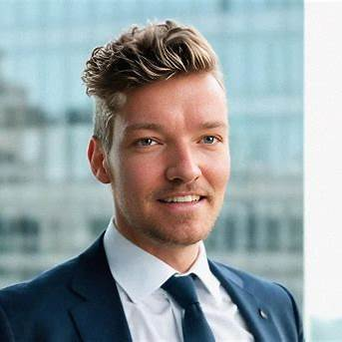<https://photoai.com/?utm_source=chatgpt.com> photo AI

<https://x.com/levelsio/photo> x.com id

Pieter Mouthan is a Dutch entrepreneur and self-taught developer who created **Photo AI**. Dutch entrepreneur and self-taught developer renowned for creating several successful startups. He developed Photo AI, an AI-driven photography service that enables users to generate realistic images and videos using artificial intelligence. Moreover, most of the information goes similar to this person. First of all his name is actually spelled Pieter Mouthan as given in the identity and his profession as an entrepreneur or self employment. Lastly, I would say that this person is the actual Pieter Mouthan as per identity requirement.

# Michael Moore

a.Owns a business

b.Lives in Manhattan

c.Widower for 7 years+

d.Has a daughter that lives in Madrid, Spain with her husband that is a doctor

e.Has twin granddaughters

f.Has a German shepherd named Jack

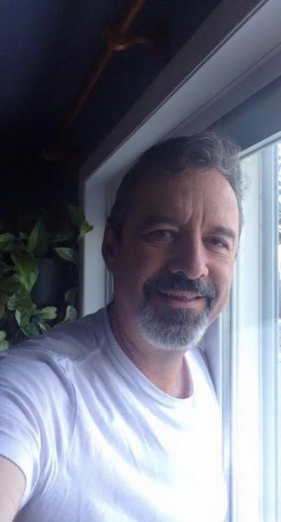I didn't find someone with this picture named Michael Moore. Maybe he doesn't even have that name or information! So I would say he is a fake or scammer.

One the other way!,

I found one people according to this information but with a few unmatched identity

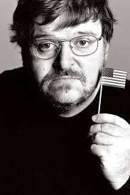<https://en.wikipedia.org/wiki/Michael_Moore>

According to his identity speaking some of the information goes with this person. For example, Michael Moore in this picture got divorced in 2014, not widower. Moreover, he does lots of business, especially as a filmmaker. Moreover, he was born in Michigan, not Manhattan which is not true about him and he does have a daughter but she doesn't live in madrid. Lastly there wasn't any updated news about his pets.

# Kenneth Dean

Lives in Washington D.C., USA

VP at a real estate development and property management company

 He is a real person with the same identity I would say. I found him on Linkedin and instagram as well with the same profile and the same profession. But there can be more people with the same name but with this photo and profession this person is real.

<https://www.linkedin.com/in/kenneth-dean-pmp/>

Teacher Comments:

~~I need some links for things you found, like social media accounts or articles.d~~